CURLEY BONDS, M.D.
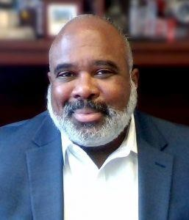
Chief Medical Officer
Los Angeles County Department of Mental Health

Curley L. Bonds, M.D., oversees all clinical practices for the Los Angeles Country Department of Mental Health (LACDMH) in his role as Chief Medical Officer.
Dr. Bonds is a board-certified adult psychiatrist with extensive experience in a variety of clinical, academic and research settings. Prior to his current position, he was the Chair of Psychiatry and Behavioral Medicine at Charles R. Drew University School of Medicine in Los Angeles and the Medical Director for Didi Hirsch Mental Health Services. His areas of expertise include healthcare disparities, cross cultural psychiatry, psychosomatic medicine, and collaborative healthcare.
Dr. Bonds is a Distinguished Fellow of the American Psychiatric Association and a Fellow of the Academy of Consultation-Liaison Psychiatry. He is a past president of the Southern California Psychiatric Society and the recipient of their 2018 Distinguished Service Award.
He completed his B.A. in sociology at Emory University and earned his M.D. from Indiana University School of Medicine.

